Project Design Phase-II
Technology Stack (Architecture & Stack)

Date | 02/10/2026
Team ID | SWTID-2026-8585
Project Name | IMPORT DATA USING TRANSFORM MAPS (SPREADSHEET)
Maximum Marks | 4 Marks

Technical Architecture:
The Deliverable shall include the architectural diagram as below and the information as per the table1 & table 2
Example: Order processing during pandemics for offline mode
Reference: https://developer.ibm.com/patterns/ai-powered-backend-system-for-order-processing-during-pandemics/
Guidelines:
Include all the processes (As an application logic / Technology Block)
Provide infrastructural demarcation (Local / Cloud)
Indicate external interfaces (third party API’s etc.)
Indicate Data Storage components / services
Indicate interface to machine learning models (if applicable)


Table-1 : Components & Technologies:
S.No | Component | Description | Technology
1 | User Interface | Authorized HR coordinator/admin uses the ServiceNow browser interface to load data, run transforms, view tables, and open reports/dashboard. | ServiceNow platform UI; browser; no separate custom UI
2 | Application Logic-1 | Load the source spreadsheet into the import-set staging table before transformation. | ServiceNow Load Data and Import Sets
3 | Application Logic-2 | Map Employee ID, Name, Email, Department, and Location to the target employee fields. | ServiceNow Transform Map and Field Maps
4 | Application Logic-3 | Match existing target rows using Employee ID; update matches and insert new IDs; review transform outcomes. | ServiceNow Coalesce on Employee ID and Transform History
5 | Database | Store staged import rows and target employee records in ServiceNow-managed tables. | u_employee_import and u_employee_test; platform-managed persistence; database engine not specified
6 | Cloud Database | No separate database service is identified; persistence remains within the ServiceNow platform. | Not in scope; ServiceNow-managed data tables
7 | File Storage | Source is an uploaded .xlsx workbook. No separate file-storage service is specified by the project. | Local workbook selected through Load Data; platform import handling
8 | External API-1 | No external API is required for the described file-based import workflow. | Not in scope
9 | External API-2 | No second external API is required for the described file-based import workflow. | Not in scope
10 | Machine Learning Model | No machine-learning model is used by the described workflow. | Not in scope
11 | Infrastructure (Server / Cloud) | ServiceNow-hosted platform instance accessed by authorized users through a browser. Exact release, hosting region, and instance configuration are not supplied. | ServiceNow SaaS instance; deployment and hosting specifics to be confirmed

Table-2: Application Characteristics:
S.No | Characteristics | Description | Technology
1 | Open-Source Frameworks | No new open-source framework is introduced; the project uses platform configuration and built-in import/report features. | ServiceNow platform
2 | Security Implementations | Limit access to import and employee records using configured roles and table/field ACLs; protect employee data and restrict dashboard sharing. | ServiceNow authentication, roles, ACLs; exact rules to be configured and verified
3 | Scalable Architecture | Use staging and transform maps to process repeatable file imports; test against the expected file size and record count before production use. | ServiceNow Import Sets and Transform Maps
4 | Availability | Depends on the availability and access configuration of the organization's ServiceNow instance; no separate availability component is specified. | ServiceNow instance; availability target to be confirmed
5 | Performance | Import processing time depends on file size, instance configuration, and data volume; measure a representative batch and set an agreed processing target. | Import Set/Transform execution; no cache, CDN, or external service in scope

Project Technical Architecture
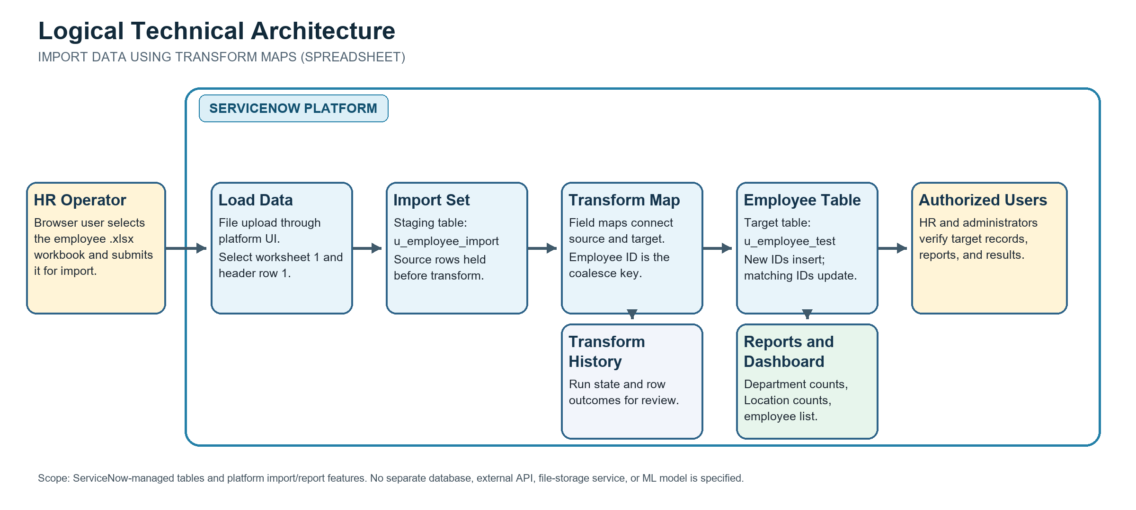
Data stays within the ServiceNow instance after upload: .xlsx -> Load Data -> u_employee_import -> Transform Map/Employee ID coalesce -> u_employee_test -> Transform History and reports/dashboard. No external database, API, or ML service is in scope.
References:
https://c4model.com/
https://developer.ibm.com/patterns/online-order-processing-system-during-pandemic/
https://www.ibm.com/cloud/architecture
https://aws.amazon.com/architecture
https://medium.com/the-internal-startup/how-to-draw-useful-technical-architecture-diagrams-2d20c9fda90d

ServiceNow documentation used for this project:
Import sets key concepts - supported spreadsheet formats and transform-map concepts - https://www.servicenow.com/docs/r/xanadu/integrate-applications/system-import-sets/c_ImportSetsKeyConcepts.html
Create a field map - source/target mapping and coalesce behavior - https://www.servicenow.com/docs/r/integrate-applications/system-import-sets/t_CreatingAFieldMap.html
ACL types - table and field access controls - https://www.servicenow.com/docs/r/platform-security/access-control/acl-rule-types.html

